

**Bachelor of Information Technology**

Semester One, 2019

General Handover Document

|  |  |
| --- | --- |
| ****Project Name:**** | SGRANCh Compendium App |
| ****Project Code:**** | 1-1-SGCRANCh-2019 |
| ****Module Code:**** | IT7x01 |

**Written by:**

|  |  |  |
| --- | --- | --- |
| Student names and contact details | | |
| Name | Phone | Email |
| Chris Simmons | 0211769080 | Christopher.Simmons@protonmail.ch |
| Taylor Everett | 0226779068 | tayloreverett@gmail.com |

**Completed Date:**

**Contents**

Introduction 3

Scope 3

Background 4

Milestones/iterations 5

Final status report 12

Current Status 12

Outstanding Issues 12

Status of Future Requirements 13

Concerns 13

Progress Reports 14

Project Progress Report 1 14

Project Progress Report 2 15

Project Progress Report 3 16

List of artefacts 17

Appendix A1: Initial documents 18

Appendix A2: Logos 30

Appendix A3: Regalia 32

Appendix A4: Orders and the Ceremonies 39

Appendix A5: Chapter Data 45

Appendix A6: Chapter Map 58

# Introduction

In this project we developed a system that uses an application for an android smart device that is accessed by logging into a MySQL and PHP server to view a variety of data, both static and dynamic. The team consist of two students (Taylor Everett and Chris Simmons) coordinating on a regular basis to develop this application for our client (Ken Burt) who is a member of an organization (The Supreme Royal Arch New Zealand).

**Why the system was built**: This project was to build an application on smart devices for members of the Royal Arch website to view and download rituals, which the users have access to. The application was originally just an idea, the core idea is to modernize members’ methods of retrieving these ritual files. The application was also required to be informative to its users in similar regards to their current website. This included a login using the current website credentials, access to their Profile, rituals, history, degree chronology, chapter finder, regalia, about app, and an addition of a glossary.

# Scope

The scope has been changed from the original proposal due to the current systems information being still made unavailable from the Client.

|  |  |  |
| --- | --- | --- |
| **Project Scope** | | |
| **Project Requirements** | **Item No.** | **Criteria** |
|  | 1 | Create an app, compatible with Android smart devices. |
|  | 2 | The App wireframe will be like a compendium. Based on similar apps, Apple Tips & Tricks, Coursera, or ManageMyHealth. |
|  | 3 | Registration/Password informational pop up. |
|  | 4 | Profile page info and add degrees & dates attained. |
|  | 5 | Ritual page will provide each degree when check to date earned to be viewed or downloaded. |
|  | 6 | Create functionality/content; Chronology of degrees, History of SGACNZ, Regalia, Glossary of words includes sound bits of proper pronunciation, chapter & council list include meeting bites & locations with map (google maps) |
| **Project Boundaries** | **Item No.** | **Criteria** |
|  | 1 | Limited the number of device compatibility to Android |
|  | 2 | Database information is unattainable at this time so we made up our own. |
|  | 3 | Website server information is unattainable created a PHP server. |
| **Project Deliverables:** | **Item No.** | **Criteria** |
|  | 1 | Initiate project development. |
|  | 2 | Wireframe layout design, flow, and the look of the application. |
|  | 3 | Create a paper prototype of wireframes for the client to test. |
|  | 4 | Test Plans; interface and backend |
|  | 5 | Application that takes form of what the Client has expressed though the development of the paper prototype. |

# Background

This Project was first focused on creating a compendium application for the client and their organization. During our first meeting, we requested a database schema, a blank version of the current websites database, and whether or not their server could support API, none of which has been made available by the completion of this document. This project iteration has been largely impacted by the lack of technical information that has not been provided. The Client has the means to attain this information but requires permission from the council which is still in progress. Because of this, the project has turned into a functional prototype instead of a finished product.

**How it has been built**: The system was initially built by analysis of the clients’ ideas in power point form and other documents as well as meetings taken place during our design phase. No information of the client’s current working system has been made available before the 21st of May, and the information provided after this date is only a vague understanding with no defined details of what is in the system.

Initially we tried developing with PhoneGap (by Adobe) but neither of us could get a finished test application to work on our phones due to incompatibility which shouldn’t have been a problem since we both met the requirements. During the development phase we switched to using Unity instead since we both have experience and knew it could meet the criteria.

# Milestones/iterations

|  |  |  |  |
| --- | --- | --- | --- |
|  | | | |
| Project Number | | 1-1-SGCRANCh-2019 | |
| Project Name | | SGCRANCh | |
| Student Name | | Student ID |
| Christopher Simmons | | 21600681 |
| Taylor Everett | | 21600252 |
| Iteration Date | | 1/03/19 |
| Iteration Detail | | | |
| **Iteration Number** | 1 | | |
| **Iteration Name** | Wireframe | | |
| **Iteration Completion Date** | 8/3/2019 | | |
| **Iteration Objective** | Outline Application | | |
| **Iteration constraints and risks** | Constraints: Wireframe is only a basic understanding of what the application would look like would and may change throughout the design phase.  Risks: Client may refuse our hand drawing and want to start over with a completely different look. | | |
|  | **Iteration Products/Outcomes** | | |
| 1. | Application basic design, rough draft to start building the application. | | |
| 2. | Drawn Prototype presented to client. | | |
| 3. | Client feedback: Made changes and added more detail on what functions the application should have. Seems to want a focus on making the application easy to use (reduced clutter). Would like to see more of what we can designed. | | |

|  |  |  |  |
| --- | --- | --- | --- |
| Student Name | Student ID | Signature | Date |
| Christopher Simmons | 21600681 |  |  |
| Taylor Everett | 21600252 |  |  |
| Approval | | | |
|  | Name | Signature | Date |
| Client | Ken Burt |  |  |
| Academic Supervisor | Iwan Tjhin |  |  |
| Project Coordinator | Scott Morton |  |  |

|  |  |  |  |
| --- | --- | --- | --- |
| Project Number | | 1-1-SGCRANCh-2019 | |
| Project Name | | SGCRANCh | |
| Student Name | | Student ID |
| Christopher Simmons | | 21600681 |
| Taylor Everett | | 21600252 |
| Iteration Date | | 8/3/2019 |
| Iteration Detail | | | |
| **Iteration Number** | 2 | | |
| **Iteration Name** | Paper Prototype | | |
| **Iteration Completion Date** | 12/4/2019 | | |
| **Iteration Objective** | Interactive representation of the Application | | |
| **Iteration constraints and risks** | Constraints: Heavily reliant on Client input. Requires more date from the client to be housed.  Risks: Client may not be able to view the Paper Prototype with his devices. | | |
|  | **Iteration Products/Outcomes** | | |
| 1. | Application design, refined draft to start building the application. | | |
| 2. | Paper Prototype presented to client through base camp and meetings. | | |
| 3. | Client feedback: Made minor changes with naming and locations of UI elements, also informed us that he will have to make a proposal to view his current system and to give us website access. | | |

|  |  |  |  |
| --- | --- | --- | --- |
| Student Name | Student ID | Signature | Date |
| Christopher Simmons | 21600681 |  |  |
| Taylor Everett | 21600252 |  |  |
| Approval | | | |
|  | Name | Signature | Date |
| Client | Ken Burt |  |  |
| Project Coordinator | Scott Morton |  |  |

|  |  |  |  |
| --- | --- | --- | --- |
| Project Number | | 1-1-SGCRANCh-2019 | |
| Project Name | | SGCRANCh | |
| Student Name | | Student ID |
| Christopher Simmons | | 21600681 |
| Taylor Everett | | 21600252 |
| Iteration Date | | 12/4/2019 |
| Iteration Detail | | | |
| **Iteration Number** | 3 | | |
| **Iteration Name** | Application Build | | |
| **Iteration Completion Date** | 26/4/2019 | | |
| **Iteration Objective** | Building the Application Interface. | | |
| **Iteration constraints and risks** | Constraints: Research into how to build an application using Phone gap and Unity to see if they would be suited to the task.  Risks: May not be able to use either development tool for the task and may have to use a native development tool such as android studio. | | |
|  | **Iteration Products/Outcomes** | | |
| 1. | Application Interface will reflect the finish design of the Paper Prototype. | | |
| 2. | Application Interface passes its Test Plan. | | |
| 3. | Client feedback: Client hasn’t been able to get the current systems information, so we decided to continue design phase and focus on making just a functional prototype. Also Changes to the; Chapters, Regalia, and Rituals selections design. | | |

|  |  |  |  |
| --- | --- | --- | --- |
| Student Name | Student ID | Signature | Date |
| Christopher Simmons | 21600681 |  |  |
| Taylor Everett | 21600252 |  |  |
| Approval | | | |
|  | Name | Signature | Date |
| Client | Ken Burt |  |  |
| Project Coordinator | Scott Morton |  |  |

|  |  |  |  |
| --- | --- | --- | --- |
| Project Number | | 1-1-SGCRANCh-2019 | |
| Project Name | | SGCRANCh | |
| Student Name | | Student ID |
| Christopher Simmons | | 21600681 |
| Taylor Everett | | 21600252 |
| Iteration Date | | 26/4/2019 |
| Iteration Detail | | | |
| **Iteration Number** | 4 | | |
| **Iteration Name** | Database Built | | |
| **Iteration Completion Date** | 30/4/2019 | | |
| **Iteration Objective** | Building the Application test database. | | |
| **Iteration constraints and risks** | Constraints: Requires Client to provide a database schema.  Risks: Client is unable to attain database schema. | | |
|  | **Iteration Products/Outcomes** | | |
| 1. | Re Create Clients Database on a local environment for implemented backend functionality. | | |
| 2. | Database has been scripted with appropriate attributes and database is populated with test data. | | |
| 3. | Client feedback: Client hasn’t been able to get the current systems information, so we decided to continue and create our own database just for testing purposes using what we assume to be MySQL. | | |

|  |  |  |  |
| --- | --- | --- | --- |
| Student Name | Student ID | Signature | Date |
| Christopher Simmons | 21600681 |  |  |
| Taylor Everett | 21600252 |  |  |
| Approval | | | |
|  | Name | Signature | Date |
| Client | Ken Burt |  |  |
| Project Coordinator | Scott Morton |  |  |

|  |  |  |  |
| --- | --- | --- | --- |
| Project Number | | 1-1-SGCRANCh-2019 | |
| Project Name | | SGCRANCh | |
| Student Name | | Student ID |
| Christopher Simmons | | 21600681 |
| Taylor Everett | | 21600252 |
| Iteration Date | | 30/4/2019 |
| Iteration Detail | | | |
| **Iteration Number** | 5 | | |
| **Iteration Name** | Backend Development | | |
| **Iteration Completion Date** | 24/5/2019 | | |
| **Iteration Objective** | Building the Application backend giving functionality. | | |
| **Iteration constraints and risks** | Constraints: Requires iteration 1-4 to be completed.  Risks: Client is unable to attain current system information. | | |
|  | **Iteration Products/Outcomes** | | |
| 1. | Application backend functionality for login profile and degree information from database. | | |
| 2. | Application passes backend Test Plan | | |
| 3. | Client feedback: N/A, reason being the client has told us from the start “To do what is needed” and doesn’t have expertise to provide much input on how this step should be handled other then what was determined in our backend test plan of use case testing. | | |

|  |  |  |  |
| --- | --- | --- | --- |
| Student Name | Student ID | Signature | Date |
| Christopher Simmons | 21600681 |  |  |
| Taylor Everett | 21600252 |  |  |
| Approval | | | |
|  | Name | Signature | Date |
| Client | Ken Burt |  |  |
| Project Coordinator | Scott Morton |  |  |

|  |  |  |  |
| --- | --- | --- | --- |
| Project Number | | 1-1-SGCRANCh-2019 | |
| Project Name | | SGCRANCh | |
| Student Name | | Student ID |
| Christopher Simmons | | 21600681 |
| Taylor Everett | | 21600252 |
| Iteration Date | | 24/5/2019 |
| Iteration Detail | | | |
| **Iteration Number** | 6 | | |
| **Iteration Name** | Development Suggestions | | |
| **Iteration Completion Date** | 31/5/2019 | | |
| **Iteration Objective** | Writing the projects Current Final Status Report. | | |
| **Iteration constraints and risks** | Constraints: General knowledge of the client’s current website system and how we may unitize or alter them.  Risks: Client can not grant permissions needed to integrate new systems with current system. | | |
|  | **Iteration Products/Outcomes** | | |
| 1. | Final Status Report of the application detailing all systems involved. | | |
| 2. | Detailing final Recommendations and outlining projects next steps for development. | | |
| 3. | Client feedback: N/A, reason being current website system information was not available in time for this project iteration, so client extended the design phase via base camp. | | |

|  |  |  |  |
| --- | --- | --- | --- |
| Student Name | Student ID | Signature | Date |
| Christopher Simmons | 21600681 |  |  |
| Taylor Everett | 21600252 |  |  |
| Approval | | | |
|  | Name | Signature | Date |
| Project Coordinator | Scott Morton |  |  |

|  |  |  |  |
| --- | --- | --- | --- |
| Project Number | | 1-1-SGCRANCh-2019 | |
| Project Name | | SGCRANCh | |
| Student Name | | Student ID |
| Christopher Simmons | | 21600681 |
| Taylor Everett | | 21600252 |
| Iteration Date | | 31/5/2019 |
| Iteration Detail | | | |
| **Iteration Number** | 7 | | |
| **Iteration Name** | Handover Documentation | | |
| **Iteration Completion Date** | 6/6/2019 | | |
| **Iteration Objective** | Documenting the project for next Iteration to continue. | | |
| **Iteration constraints and risks** | Constraints: Ability to decipher Student handbook to create documentation correctly.  Risks: Not completing task on time since extensions are not possible. | | |
|  | **Iteration Products/Outcomes** | | |
| 1. | Project Product Document completed. | | |
| 2. | Handover Document completed. | | |
| 3. | Client feedback: Ken has seen and played with our latest build as of May 31st, 2019, He is very happy with what we have made and is excited to show more members. “Application as it is right now is 98% done, with the remainder being spelling errors and the help menu.” said Ken. | | |

|  |  |  |  |
| --- | --- | --- | --- |
| Student Name | Student ID | Signature | Date |
| Christopher Simmons | 21600681 |  |  |
| Taylor Everett | 21600252 |  |  |
| Approval | | | |
|  | Name | Signature | Date |
| Project Coordinator | Scott Morton |  |  |

# Final status report

## **Current Status**

The purpose of this status report is to hand over the project to a new project team since the project is still incomplete and not part of the client’s system in any way and is independently running on Whitireia’s network only.

The application works via login to access (view only) all personal data, which would be profile information and degrees earned to enable the appropriate rituals to be viewed or downloaded. All data needs to be pre-existing in the database, so inserting new data as we understand it is only to be done via website or admin. Once the pre-existing user is logged in, they should have full access to the applications tabs and data other than rituals they have not earned.

**What has been built:** What wehave built so far is a functional prototype application within Unity (2018.3.12f1) using a MySQL server as a database with PhpMyAdmin, and a PHP 7 server as an API. The application works by posting the user input to a form, to the PHP (login.php) which then connects to the database, checks and fetches the data through MySQL query. Once the data that was inputted through the form has been passed, a message of success or failure will return to the application via PHP to indicate the information was valid or invalid. If valid the user will have access and the application which will store the Users ‘LOGIN_ID’ and ‘NZMEMBERSHIP_ID’ into global values. This is so the correct profile and degree information can be fetched and displayed within the application for that user.

The user should be able to tap any other tab and have access to an array of data such as; text, images and sound bites. The only tab that has limited access is ‘Ceremonial’ which once navigated through to ‘Rituals’. The application would check to see if the user’s degree table has access to each ritual via ‘not null’.

## Outstanding Issues

**What is still to be done:** Analysis of the client’s current systems and integration with the project application so it may access client data required to login.

The current build seems to run into slowdown issues with scrolling on pages such as regalia/order select/insignia. This could be an optimisation issue, to best find a resolution to these slowdowns, the next iteration can check with DoozyUI’s store page and in the description find help with the links they have provided.

<https://assetstore.unity.com/packages/tools/gui/doozyui-complete-ui-management-system-138361>

Application requires a stress testing on Android and IOS devices, such tests have not been implemented as of the completion of this document.

## Status of Future Requirements

For the future of this project we see two possible options to continue for the next iteration, one would be to and continue the development by improving and refine upon the application we have done. The other would be to wait and attain all critical systems information that needs to be provided by the client.

**Option 1: Our Recommendation** is to continue the design phase**;** this can be done by having more meetings with the client (Ken) to attain more input. The client is more than happy to have open conversations on Basecamp and through email. One method would be to build multiple versions of the application and have Ken experience them by having him play with them. This would make the core focus of the iteration on testing and theory. The application in this iteration should be built for the IOS as well as Android so the client can experience these builds, this would require a developer account with Apple which would be considered for the budget.

**Option 2:** It is our recommendation that the next iteration of the project should not continue until the client has released specifics of their current systems. On the 21st of May Ken told us he had talked to a database administrator; we are unsure what database this was for or how many there are (we think there is only two). The project requires the database schemas, or a blank version of the current database, and whether or not their server could support API.

### Concerns

We are also very concerned about the database security, whether or not encryption has been implemented for login, maybe use salt and hash or some other kind of encryption. It is a legacy system so it may or may not be implemented, this should be addressed.

A possible threat to the API is SQL injection, there are methods to address this issue, more research is needed to implement them, one option is to use PDO instead of MySQLi for query.

Data that is already on the application could be a security concern in regard to the ritual files, a user could take apart the application and view rituals they don’t have access to. Reason why the rituals are inside the application was to allow users to view them within the application, other methods to store these documents could be explored but concerns of who can see what and when depends on the client and how well they want to restrict access.

# Progress Reports

|  |  |  |
| --- | --- | --- |
| Project Progress Report 1 | | |
| **Project** | | |
| **Project Number** | 1-1-SGCRANCh-2019 | |
| **Project Name** | SGCRANCh | |
| **Student Name** | **Student ID** |
| *Christopher Simmons* | *21600681* |
| *Taylor Everett* | *21600252* |
| **Report Date** | *24/03/19* |
| **Report** | | |
| **Project progress to date** | | |
| **Iteration 1:** The progress made since the meeting with the client has resulted in wireframe of the intended application. The team has designed the application look like an Apple application known as ‘Tips & Tricks’ and with the use of ‘marvelapp.com’ we have made a paper prototype so the Client may be able to see the intended outcome of our development.  **Iteration 2:** We are currently in progress researching our possible requirements for different methods of making our application. Where our client is focused on compatibility with Android and Apple smart devices, we believe we can provide a larger amount of compatibility with the use of PhoneGap. | | |
| **Work to do** | | |
| **Iterations 3:** We may have to give ourselves some time to learn how to develop with PhoneGap to really test it’s a viable option by completing the front end of the application then Testing usability. We the students will be give ourselves at least 2 weeks to complete this task, we both have used Unity is the past if PhoneGap is found to be not viable.  **Iterations 4:** Obtain website and Database information so we can recreate the client’s current system to develop the application functionality. Mission Critical. | | |
| **Project issues and solutions** | | |
| Our academic supervisor is unavailable for an unforeseeable amount of time, in the mean time the project coordinator has taken the role.  Presently, we have yet to get the required Data from the client in regard to their current system, we are in progress to setting up next meeting with Client where we will also show off the paper prototype. | | |

|  |  |  |
| --- | --- | --- |
| Project Progress Report 2 | | |
| **Project** | | |
| **Project Number** | 1-1-SGCRANCh-2019 | |
| **Project Name** | SGCRANCh | |
| **Student Name** | **Student ID** |
| *Christopher Simmons* | *21600681* |
| *Taylor Everett* | *21600252* |
| **Report Date** | *1/05/19* |
| **Report** | | |
| **Project progress to date** | | |
| **Iteration 3 Application Build:** This first step in coding for the final prototype and will be designed after the approved Paper Prototype. Known as the interface of the application. We chose Unity to develop with since we couldn’t get PhoneGap to work on any of our devises.  **Iteration 4 Database Built:** This is required to have functionality for the website and is needed for future iterations and was to be provided by the client when available, it has not. We have created a database using just the information they have accumulated, meaning it will not have the ability to connect to the current system used by the Client. The database is required for Login, User Profile, and Ritual/Degrees information. We have created proper data tables and information to populate them which will show a variety of users. | | |
| **Work to do** | | |
| **Iterations 5 Backend Development:** The final coding development cycle will be responsible for the applications ability to connect to the database and allow users to login and see their personal data, as well as have access to general information. This could be coded using either C#, a Test Plan will be written for functionality.  **Iterations 6 Development Suggestions:** This stage, the Prototype Application should be built, and the Test Plans will have been implemented. A report detailing the next steps for the Project as well as possible improvements that can be made on either the systems in place or functionality on the application. We couldn’t obtain the Clients’ database information so steps on how the application could be connected will be detailed in a report. | | |
| **Project issues and solutions** | | |
| 1. Client hasn’t been able to get the permissions to give us access to their website or database, causing us to have to limit the Project from a fully functioning application to a functional Prototype.  2. Client has now started implementing new functions and UI elements to the application causing scope creep, at first it scared us, but we then realized we could just extend the Paper Prototype phase since now we wouldn’t have time to integrate the client systems. | | |

|  |  |  |
| --- | --- | --- |
| Project Progress Report 3 | | |
| **Project** | | |
| **Project Number** | 1-1-SGCRANCh-2019 | |
| **Project Name** | SGCRANCh | |
| **Student Name** | **Student ID** |
| *Christopher Simmons* | *21600681* |
| *Taylor Everett* | *21600252* |
| **Report Date** | *29/05/19* |
| **Report** | | |
| **Project progress to date** | | |
| **Iteration 5 Backend Development:** This was final coding development cycle it is responsible for the applications ability to connect to the database and allowing users to login and see their personal data, as well as have access to general information.  This was coded using C# and PHP and in this iteration a Test Plan has been written.  **Iteration 6 Development Suggestions:** The Prototype Application was built, and the Test Plans have been implemented. A report detailing the next steps for the Project as well as possible improvements that can be made on either the systems in place or functionality on the application known as the Handover Document.  **Iteration 7 Handover Documentation:** Handover documents includes all artefacts relating to the project such as notes from the client, communications via Basecamp, Suggestion report, and source code with inline commenting. Also, a report on resources used for the Project and explanations on how to use them. | | |
| **Work to do** | | |
| **Iteration 8 Finalize Project:** Ensure the Project is going to operate for our showcase and start creating our poster to be on display. | | |
| **Project issues and solutions** | | |
| 1. Hosting for the DB and the PHP we had been using a local method for development and didn’t think about the next steps for the application to work on a mobile device. Solved by the help of Geoff who will host services on the school network.  2. Client has finally talked to the webmasters and has been met with push back, further analysis by our clients’ organization is required.  3. Client has meet with the Database Administrator and they seem to understand the task at hand and think it’s a good idea that is going to need some approval by the council, comments made in Kens’ message made us question which Database Administrator he was talking to. | | |

# List of artefacts

1. Project Product
   1. Unity Build .APK file
      1. This is the application to be loaded on an Android device

* + 1. [Git.lab Builds APKs -Installer Folder](http://git.pcsupport.ac.nz/21600681/Unity---RoyalArchApp---DoozyUI)
  1. Unity Project source files
     1. Unity project file complete with Assets
     2. [Git.lab](http://git.pcsupport.ac.nz/21600681/Unity---RoyalArchApp---DoozyUI)
  2. Project Product Document
     1. File name Project_Proposal_SCRANCh.docx
     2. Found student Dropbox Via Moodle

1. Project user Accounts
   1. Paper Prototype
      1. <https://marvelapp.com/>
      2. Username: GitHubStudent@protonmail.com
      3. Password: GitHubIsCool07
   2. Unity Account for UI add-on
      1. Addon active time on the account is Indefinite
      2. Login in using Unity Hub application
      3. Username: GitHubStudent@protonmail.com
      4. Password: GitHubIsCool07
2. Backend Server-Side Source files
   1. PHP 7 server code
      1. Complete with commenting
      2. [Git.lab PHP/sqlconnect Folder](http://21600252@git.pcsupport.ac.nz/21600681/Unity---RoyalArchApp---DoozyUI.git)
   2. Data Base MySQL Script
      1. Lightly commented for insert data
      2. [Git.lab Database Folder](http://git.pcsupport.ac.nz/21600681/Unity---RoyalArchApp---DoozyUI)
3. Client Documents
   1. Client notes, power point, detail documents, and images
      1. Found in Appendix A1-A6
      2. [Git.lab Client Files Folder](http://git.pcsupport.ac.nz/21600681/Unity---RoyalArchApp---DoozyUI)

<http://git.pcsupport.ac.nz/21600681/Unity---RoyalArchApp---DoozyUI>

# Appendix A1: Initial documents

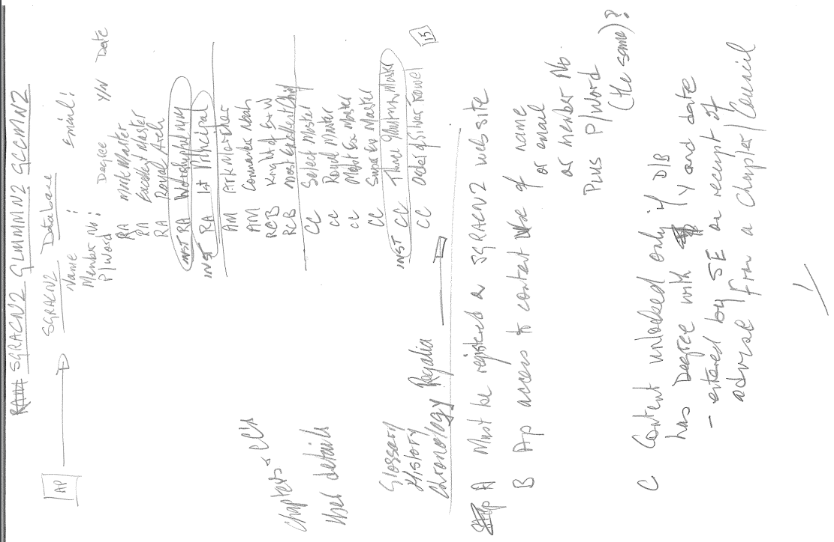

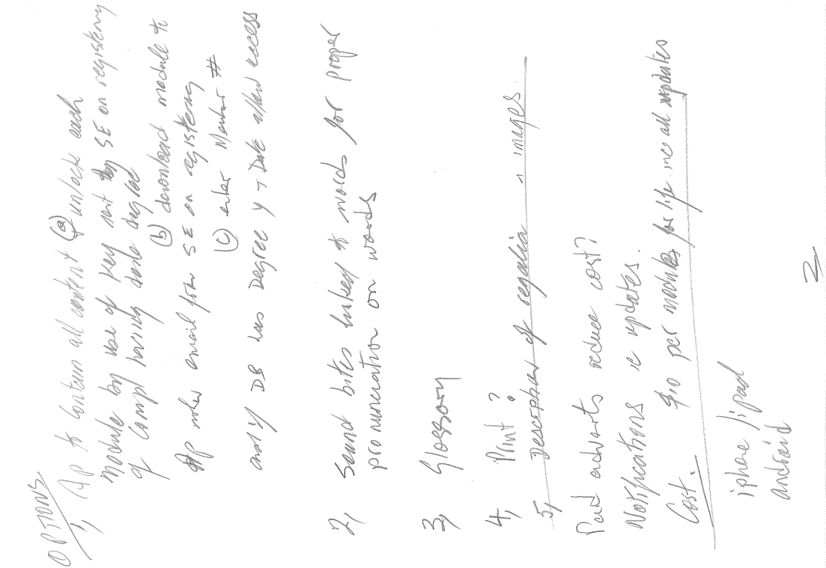

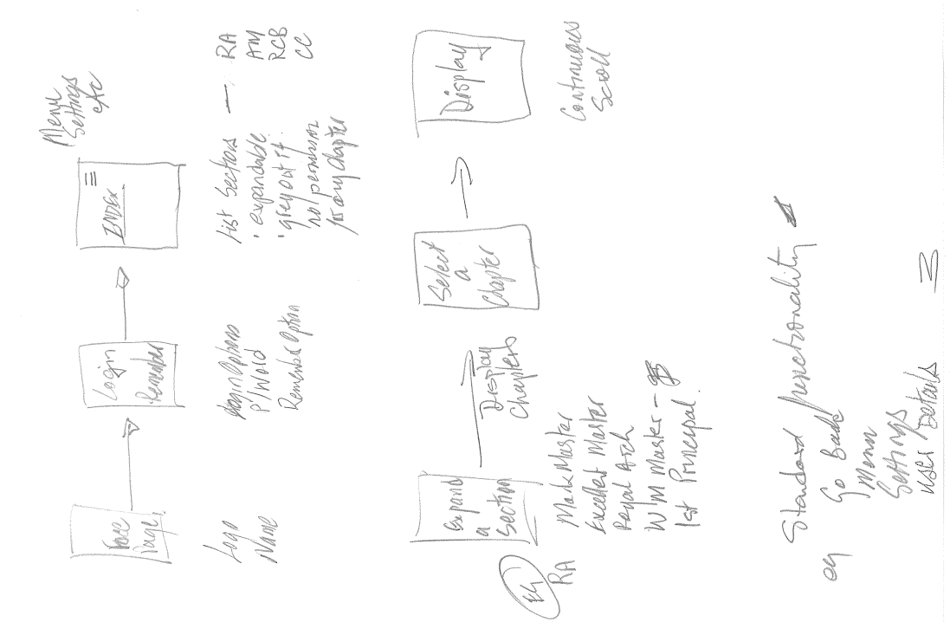

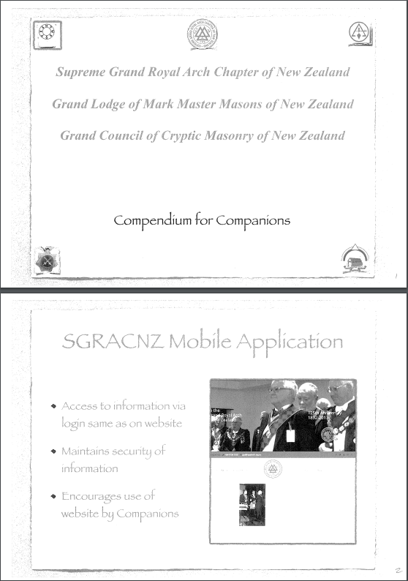

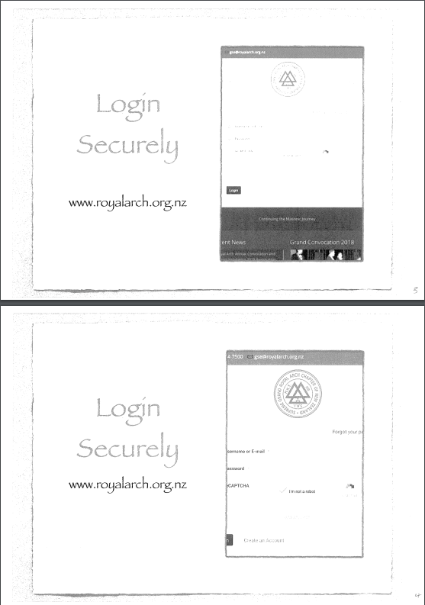

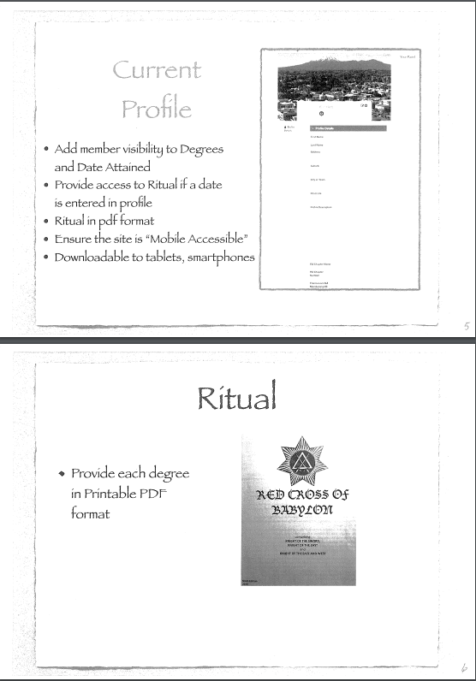

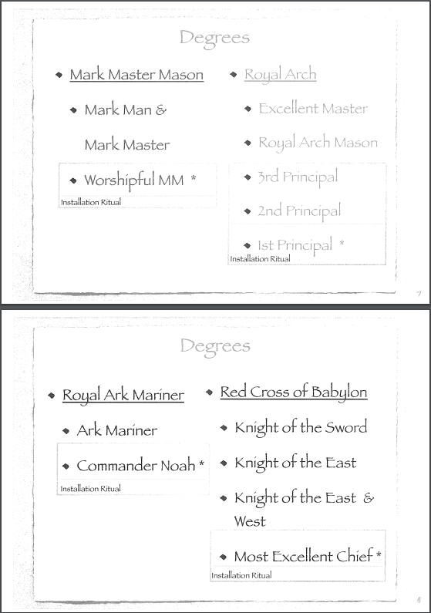

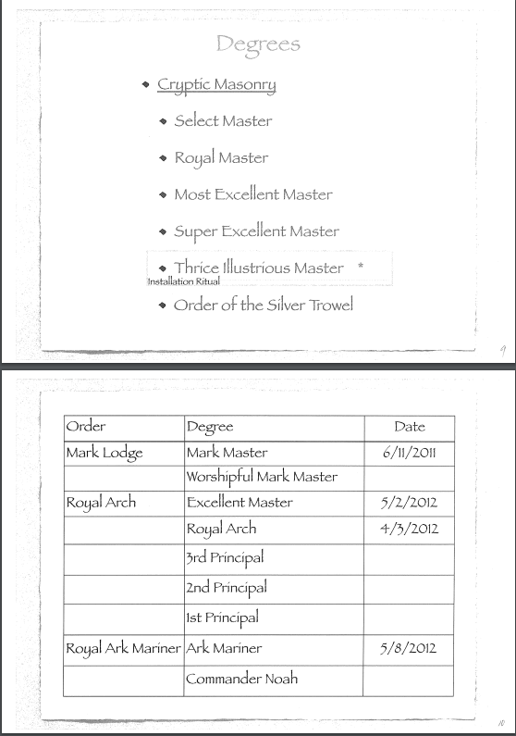

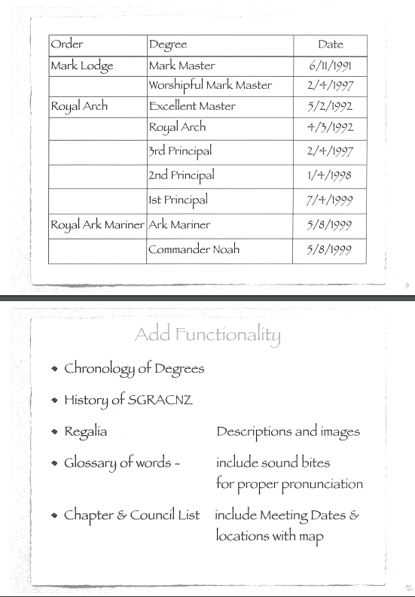

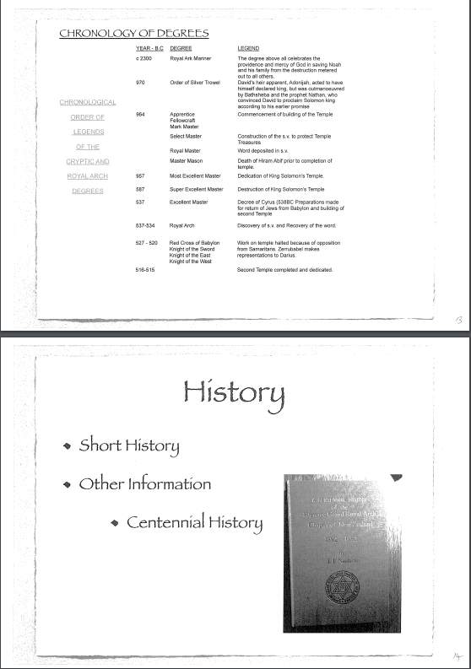

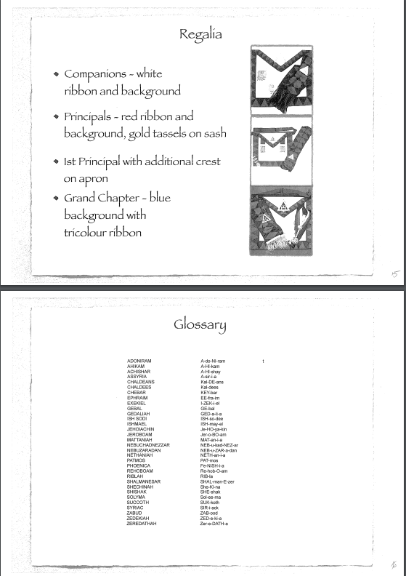

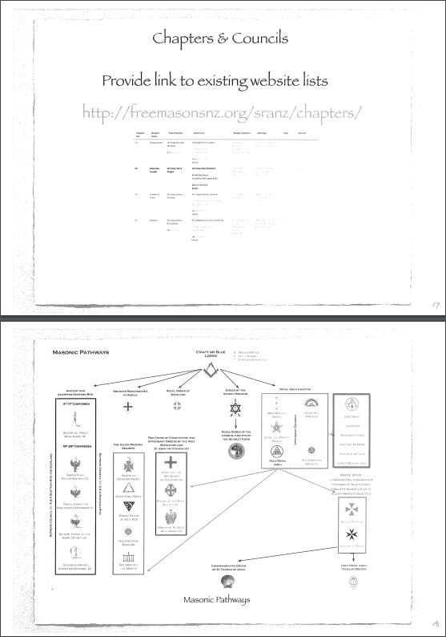

# Appendix A2: Logos

LOGOS for the Rituals, and the Regalia

The SGRACNZ logo is for the Regalia pages as they have specific regalia

|  |  |
| --- | --- |
|  | MARK |
|  | ROYAL ARK MARINER |
|  | RED CROSS OF BABYLON |
|  | ROYAL ARCH |
|  | CRYPTIC COUNCIL |
|  | SUPREME GRAND ROYAL ARCH CHAPTER OF NEW ZEALAND  Abbreviate to  SGRACNZ |

# Appendix A3: Regalia

**ROYAL ARCH DEGREE REGALIA**

**CLOTHING**

|  |  |
| --- | --- |
| **COMPANION** | |
| **APRON** | |
|  | The Apron is rectangular in shape 32 cm x 40 cm in size with a triangular flap on the top with a WHITE belt attached, with the snake or serpent type buckle. It has the white lambskin base with the royal blue and red triangular border 5.5cm in width. The same pattern is on the lower edges of the flap which is 30 cm in width. In the centre of the triangular flap is mounted a gold Royal Arch equilateral triangle with a WHITE background. A pair of gold tassels mounted on a WHITE ribbon 50cm in width are fixed 7 cm in from each side edge (to the outer edge of the ribbon). |
| **SASH** | |
|  | The Sash is in the colours of Royal Blue Triangles along each edge and red diamonds extending edge to edge, 10cm in width and a length suitable for the wearer. Where the two sides of the sash are sewn together is secured a gold equilateral triangle (same as the apron) with a WHITE background and attached with the base 12 cm from the end of the sash and at the end tassels of royal blue, red in colour and 8 cm in length. |
| **2ND & 3RD PRINCIPALS** | |
| **APRON** | |
|  | The Apron is rectangular in shape 32 cm x 40 cm in size with a triangular flap on the top with a RED belt attached, with the snake or serpent type buckle. It has the white lambskin base with the royal blue and red triangular border 5.5cm in width. The same pattern is on the lower edges of the flap which is 30 cm in width. In the centre of the triangular flap is mounted a gold Royal Arch equilateral triangle with a RED background. A pair of gold tassels mounted on a RED ribbon 50cm in width are fixed 7 cm in from each side edge (to the outer edge of the ribbon). |
| **SASH** | |
|  | The Sash is in the colours of Royal Blue Triangles along each edge and red diamonds extending edge to edge, 10cm in width and a length suitable for the wearer. Where the two sides of the sash are sewn together is secured a gold equilateral triangle (same as the apron) with a RED background and attached with the base 12 cm from the end of the sash and at the end tassels are gold and 8 cm in length. |
| **1ST PRINCIPAL** | |
| **APRON** | |
|  | The Apron is rectangular in shape 32 cm x 40 cm in size with a triangular flap on the top with a RED belt attached, with the snake or serpent type buckle. It has the white lambskin base with the royal blue and red triangular border 5.5cm in width. The same pattern is on the lower edges of the flap which is 30 cm in width. In the centre of the triangular flap is mounted a gold Royal Arch equilateral triangle with a RED background. A pair of gold tassels mounted on a RED ribbon 50cm in width are fixed 7 cm in from each side edge (to the outer edge of the ribbon) AND the 1st Principal’s badge 9-9.5 cm in circumference is added in the centre of the apron 6 cm from the bottom edge, with a gap between the triangular apron border.. |
| **SASH** | |
|  | The Sash is in the colours of Royal Blue Triangles along each edge and red diamonds extending edge to edge, 10cm in width and a length suitable for the wearer. Where the two sides of the sash are sewn together is secured a gold equilateral triangle (same as the apron) with a RED background and attached with the base 12 cm from the end of the sash and at the end tassels are gold and 8 cm in length. |

**BREAST JEWELS**

|  |  |
| --- | --- |
| **COMPANION** | |
|  | The Companion’s Jewel is of the design approved by Grand Chapter mounted on a white ribbon. A rectangular frame is placed at the half way point on the ribbon. The overall length of the ribbon is 8 cm and the width is 3.8 cm. |
| **PRINCIPALS** | |
|  | The Principal’s Jewel is of the design approved by Grand Chapter mounted on a red ribbon. A rectangular frame is placed at the half way point on the ribbon. The overall length of the ribbon is 8 cm and the width is 3.8 cm. |
| **PAST PRINCIPAL** | |
|  | The Past Principal’s Jewel is a gift from the Chapter and can be the design generally in use or can be of a design of the Chapter’s choosing |

**INSIGNIA**

|  |  |
| --- | --- |
| **OFFICERS COLLAR** | |
| http://www.ghlilley.com.au/site/DefaultSite/filesystem/images/masonicItems/thumbs/royal-arch-chapter/RAC-030.jpg | The officer’s collar is red to maroon in colour and is x cm in width and measures x cm from the top of the collar to the jewel mount. The jewel is x cm in diameter and the correct symbol for the officer wearing the collar. A gold braid plus a half globe is fixed along the seam where the collar joins at the jewel mount.  A gold braid can be affixed around the inner and outer edge or in the centre of the 1st Principal’s Collar. |
| **ROBES** | |
| To come | The robes are 1st Principal Red, 2nd Principal Purple and 3rd Principal Blue.  The Sojourners and the Scribes wear white robes and the scribes only can wear mortarboards. |
| **OFFICERS JEWELS** | |
|  | **1st Principal** Triangle plus crown on rosette |
|  | **2nd Principal** Triangle plus all seeing eye on rosette |
|  | **3rd Principal** Triangle plus Open Book on rosette |
|  | **Scribe E.** Triangle plus crossed quills |
|  | **Scribe N.** Triangle plus crossed quills |
|  | **Treasurer** Triangle plus key |
|  | **D.C.** Triangle plus crossed batons |
|  | **Asst.D.C** Triangle plus inverted crossed batons |
|  | **1st Sojourner** Triangle plus square on a rosette |
|  | **2nd Sojourner** Triangle plus Square |
|  | **3rd Sojourner** Triangle alone |
|  | **Supt of Works** Triangle plus pickaxe, shovel, crowbar |
|  | **Almoner** Triangle plus purse |
|  | **Organist** Triangle plus harp |
|  | **Steward** Triangle plus cornucopia |
|  | **Janitor** Triangle plus dagger |

# Appendix A4: Orders and the Ceremonies

Orders and the Ceremonies including rules of access to the Ceremonial portion of the app.

|  |  |  |
| --- | --- | --- |
| **Order** | **Ceremonial Ritual** | **Who can see** |
| Mark |  |  |
|  | Mark Master | Mark Master  Worshipful Mark Master |
|  | Worshipful Mark Master Installation | Mark Master  Worshipful Mark Master |
|  | Board of Installed WMM | Worshipful Mark Master |
| Royal Arch |  |  |
|  | Excellent Master | Excellent Master  Royal Arch  Any Principal |
|  | Royal Arch | Royal Arch  Any Principal |
|  | Principals Installation | Royal Arch  Any Principal |
|  | Conclave of Installed Principals | 1st Principal |
| Royal Ark Mariner |  |  |
|  | Ark Mariner | Ark Mariner  Commander Noah |
|  | Commander Noah Installation | Commander Noah |
| Red Cross of Babylon |  |  |
|  | Knight Mason (Red Cross) | Red Cross  Most Excellent Chief |
|  | Most Excellent Chief Installation | Most Excellent Chief |
| Cryptic Council |  |  |
|  | Select Master | Select Master  Royal Master  Most Excellent Master  Super Excellent Master  Thrice Illustrious Master  Order of the Silver Trowel |
|  | Royal Master | Royal Master  Most Excellent Master  Super Excellent Master  Thrice Illustrious Master  Order of the Silver Trowel |
|  | Most Excellent Master | Most Excellent Master  Super Excellent Master  Thrice Illustrious Master  Order of the Silver Trowel |
|  | Super Excellent Master | Super Excellent Master  Thrice Illustrious Master  Order of the Silver Trowel |
|  | Thrice Illustrious Master Installation | Super Excellent Master  Thrice Illustrious Master  Order of the Silver Trowel |
|  | Conclave of Installed TIM | Thrice Illustrious Master  Order of the Silver Trowel |
|  | Order of the Silver Trowel | Order of the Silver Trowel |

The above is of course dependent on the degree and date of the ceremony being entered in the tables in the Individual members Record that will surface in the “My Profile”.

As agreed it will show each of the above listed under “Ceremonial Ritual” but greyed out if no date is recorded in the Member Record. A popup on the greyed out line will display the following:

SGRACNZ  records do not currently show you as having completed this degree.  Please check in "My Profile" which lists all degrees you are recorded as having completed.  If you have certificates for any degree not listed please scan and email them to Grand Scribe Ezra with a request to update your profile.  If you do not have a certificate you will need to discuss with your Chapter Scribe to supply other proof.

The below is a listing of the way the degrees and dates are shown in the Royal Arch membership website and held in the database. There is also an associated comment which shows the Chapter or Council the degree ceremony was held.

Be aware that a person may have more than one entry for:

* Worshipful Mark Master of a Mark Lodge
* First, Secord or Third Principal of a Chapter
* Thrice Illustrious Master of a Cryptic Council

Therefor maybe only look for the earliest date of that degree.

In the example below I have stripped out duplicates.

|  |  |  |  |
| --- | --- | --- | --- |
| **Degrees** | | | |
| **Degree** | **Date** | **Comment** |  |
| Mark Degree | 06/11/1991 | Whetu-Kairangi No 60 |  |
| Excellent Degree | 05/02/1992 | Whetu-Kairangi No 60 |  |
| Royal Arch Degree | 04/03/1992 | Whetu-Kairangi No 60 |  |
| Ark Mariner | 06/05/1992 | Whetu-Kairangi No 60 |  |
| Red Cross | 03/03/1993 | Whetu-Kairangi No 60 |  |
| Worshipful Mark Master | 02/04/1997 | Whetu-Kairangi No 60 |  |
| Most Excellent Chief | 05/08/1999 | Wellington No 62 |  |
| Worshipful Commander Noah | 12/10/1999 | Tutanekai-Hinemoa No. 92 |  |
| Cryptic - Royal Master | 28/02/2000 | Russell CC # 51 |  |
| Cryptic - Select Master | 22/05/2000 | Russell CC # 51 |  |
| Cryptic - Super Excellent Master | 28/08/2000 | Russell Cryptic Council No 51 |  |
| Cryptic - Most Excellent Master | 25/08/2003 | Russell CC # 51 |  |
| Thrice Illustrious Master | 22/11/2010 | Russell Cryptic Council No 51 |  |
| Order of the Silver Trowel | 03/03/2017 | Council of the Silver Trowel No 111 |  |

|  |  |  |  |
| --- | --- | --- | --- |
| **Chapter Principals** | | | |
| **Chapter No.** | **Rank** | **Start Date** | **End Date** |
| Whetu-Kairangi No. 60 | First Principal | 07/04/1999 | 05/04/2000 |
| Whetu-Kairangi No. 60 | Second Principal | 01/04/1998 | 07/04/1999 |
| Whetu-Kairangi No. 60 | Third Principal | 02/04/1997 | 01/04/1998 |

To further assist I include below my record scraped from the membership website. (I have removed some information that does not need to be surfaced in the app. As well as removing duplicate ceremonials eg I have been a Principal 12 times ☺ over the years.

I recommend that an initial check should be made to the field “Status” to ensure that the word “Active” is recorded. If not then do not allow access to any pages underlying the Ceremonial Section on the page under login. I have displayed this field in RED

I trust this will further your understanding, but remember any questions I am available.

|  |  |
| --- | --- |
| **Individual Membership Details (Freemasonry)** | |
| **Name** | Kenneth Robert Burt |
| **Birth Date** |  |
| **Occupation** |  |

|  |  |
| --- | --- |
| **Basic Details (Freemasonry)** | |
| **Proposed** | , |
| **Initiated** | 18/05/1978 , The Herbert Teagle-Taia Lodge |
| **Passed** | 21/09/1978 , The Herbert Teagle-Taia Lodge |
| **Raised** | 07/03/1979 , The Brooklyn |

|  |  |  |  |
| --- | --- | --- | --- |
| **Individual Membership Details** | | | |
| **Title** | R E Comp |  |  |
| **Status** | Active |  |  |
| **Cryptic** | Yes |  |  |
| **Joined Date** | 06/11/1991 |  |  |
| **Joined Chapter** | 62 |  |  |
| **Joined Details** | tfr from WhetuKairangi |  |  |

|  |  |  |  |
| --- | --- | --- | --- |
| **Degrees** | | | |
| **Degree** | **Date** | **Comment** |  |
| Mark Degree | 06/11/1991 | Whetu-Kairangi No 60 |  |
| Excellent Degree | 05/02/1992 | Whetu-Kairangi No 60 |  |
| Royal Arch Degree | 04/03/1992 | Whetu-Kairangi No 60 |  |
| Ark Mariner | 06/05/1992 | Whetu-Kairangi No 60 |  |
| Red Cross | 03/03/1993 | Whetu-Kairangi No 60 |  |
| Worshipful Mark Master | 02/04/1997 | Whetu-Kairangi No 60 |  |
| Most Excellent Chief | 05/08/1999 | Wellington No 62 |  |
| Worshipful Commander Noah | 12/10/1999 | Tutanekai-Hinemoa No. 92 |  |
| Cryptic - Royal Master | 28/02/2000 | Russell CC # 51 |  |
| Cryptic - Select Master | 22/05/2000 | Russell CC # 51 |  |
| Cryptic - Super Excellent Master | 28/08/2000 | Russell Cryptic Council No 51 |  |
| Cryptic - Most Excellent Master | 25/08/2003 | Russell CC # 51 |  |
| Thrice Illustrious Master | 22/11/2010 | Russell Cryptic Council No 51 |  |
| Order of the Silver Trowel | 03/03/2017 | Council of the Silver Trowel No 111 |  |

|  |  |  |  |  |
| --- | --- | --- | --- | --- |
| **Chapter Membership** | | | | |
| **Chapter No.** | **Joined Date** | **Current Status** | **Date** | **Capitation** |
| Wellington No. 62 | 06/10/2005 | Active | 06/10/2005 | Yes |
| Whetu-Kairangi No. 60 | 06/11/1991 | Transferred | 06/10/2005 | No |

|  |  |  |  |
| --- | --- | --- | --- |
| **Chapter Principals** | | | |
| **Chapter No.** | **Rank** | **Start Date** | **End Date** |
| Whetu-Kairangi No. 60 | First Principal | 07/04/1999 | 05/04/2000 |
| Whetu-Kairangi No. 60 | Second Principal | 01/04/1998 | 07/04/1999 |
| Whetu-Kairangi No. 60 | Third Principal | 02/04/1997 | 01/04/1998 |
|  |  |  |  |

|  |  |  |  |
| --- | --- | --- | --- |
| **Cryptic Council** | | | |
| **Council** | **Joined Date** | **Current Status** | **Date** |
| Russell No. 51 | 28/02/2000 | Active | 22/09/2017 |
| Silver Trowel No. 111 | 03/03/2017 | Active | 26/09/2017 |

|  |  |  |  |
| --- | --- | --- | --- |
| **Cryptic Council Officer** | | | |
| **Council** | **Rank** | **Start Date** | **End Date** |
| Russell No. 51 | Thrice Illustrious Master | 22/11/2010 | 22/11/2011 |
| Russell No. 51 | Depute Master | 21/11/2009 | 20/11/2010 |
| Russell No. 51 | Principal Conductor of Works | 22/11/2008 | 21/11/2009 |

|  |  |  |  |
| --- | --- | --- | --- |
| **Grand Ranks** | | | |
| **Rank** | **Start Date** | **End Date** |  |
| Grand Standard Bearer | 13/03/2010 | 10/03/2012 |  |
| Grand Director of Ceremonies | 07/03/2015 | 04/03/2017 |  |
| Grand Superintendent | 04/03/2017 |  |  |

|  |  |  |  |
| --- | --- | --- | --- |
| **Jewels, 5 Year Bars and Awards** | | | |
| **Date** | **Type** | **Comment** |  |

# Appendix A5: Chapter Data

|  |  |  |  |  |  |  |  |  |
| --- | --- | --- | --- | --- | --- | --- | --- | --- |
| Chapters | | | | | | | | |
| **Division** | **District** | **Chapter No.** | **Chapter Name** | **Chapter Address** | **Meetings** | **Map** | **First Principal** | **Scribe Ezra** |
| Northern | Northland | #27 | Whangarei | 17 Albert St, | 1st Tue all months except Jan & Feb (Installation Nov) | [Click For Directions](https://goo.gl/maps/otecwMwn8S32) | **VE Comp Noel Canning** | **RE Comp G B Morris** |
|  |  |  |  | Whangarei 0110 |  |  |  | 8a Carr St |
|  |  |  |  |  |  |  |  | Kamo |
|  |  |  |  |  |  |  |  | Whangarei 0112 |
|  |  |  |  |  |  |  |  | **Tel:** 09 435 1139 |
|  |  |  |  |  |  |  |  | [Email: graym@kol.co.nz](mailto:graym@kol.co.nz) |
| Northern | Northland | #65 | Bay of Islands (DORMANT) | 2 Cobham Rd, | 3rd Monday all months except Jan & Feb (Installation Aug) | [Click For Directions](https://goo.gl/maps/aDuLMn7AZGD2) | **VE Comp Leonard Field** | **VE Comp T W Hawtin** |
|  |  |  |  | Kerikeri 0230 |  |  |  | 30 Mawson Ave, |
|  |  |  |  |  |  |  |  | RD 2 |
|  |  |  |  |  |  |  |  | Kerikeri 0295 |
|  |  |  |  |  |  |  |  | **Tel:** 09 407 6136 |
|  |  |  |  |  |  |  |  | [Email: twhawtin@kinect.co.nz](mailto:twhawtin@kinect.co.nz) |
| Northern | Northland | #71 | Hokianga | 1/7577 State Highway 1 | 1st Wed all months except Jan, Feb & Dec (Installation Jul) | [Click For Directions](https://goo.gl/maps/9tPsvSkHJ9t) | **VE Comp Ralph Barber** | **VE Comp Wayne Maday** |
|  |  |  |  | Ohaeawai 0472 |  |  |  | 17 Charlotte Kemp Drive, |
|  |  |  |  |  |  |  |  | Kerikeri |
|  |  |  |  |  |  |  |  | **Tel:** 09 407 8761 |
|  |  |  |  |  |  |  |  | [Email:wmaday@kinect.co.nz](mailto:wmaday@kinect.co.nz) |
| Northern | Northland | #80 | Kaipara - Mahurangi | Old Masonic Hall | 4th Thur Feb, Apr, Jun,Aug,Oct 2nd Thur Dec (Installation Jun) | [Click For Directions](https://goo.gl/maps/jPqicJpGiZr) | **VE Comp Ian Kerr** | **RE Comp David Starr G Supt** |
|  |  |  |  | 3 Baxter St, |  |  |  | P O Box 54, |
|  |  |  |  | Warkworth 0910 |  |  |  | Warkworth 0941 |
|  |  |  |  |  |  |  |  | **Tel:** 09 425 5664 |
|  |  |  |  |  |  |  |  | [Email: starrdust@xtra.co.nz](mailto:starrdust@xtra.co.nz) |
| Northern | Auckland | #9 | The Auckland | 181 Khyber Pass Road, | 1st Thur Mar, May, Jul, Oct, Dec (Installation July) | [Click For Directions](https://goo.gl/maps/64zy1sSUxum) | **VE Comp Graham Fitzpatrick** | **VE Comp K J Galley PGDC** |
|  |  |  |  | Grafton |  |  | **Tel:** 09 520 5293 | 64 Hattaway Ave, |
|  |  |  |  | Auckland 1023 |  |  |  | Bucklands Beach |
|  |  |  |  |  |  |  |  | Auckland 2012 |
|  |  |  |  |  |  |  |  | **Tel:** 09 534 3601 |
|  |  |  |  |  |  |  |  | [Email: kgalley@actix.co.nz](mailto:kgalley@actix.co.nz) |
| Northern | Auckland | #52 | North Shore City | 5 William Laurie Place, | 1st Thur Apr, Jun, Aug, Sep, Oct (Installation Sep) | [Click For Directions](https://goo.gl/maps/oDTVM34M91u) | **VE Comp Henri-Noel Venturini** | **VE Comp David Barr** |
|  |  |  |  | Albany 0632 |  |  |  | 24/12 Coronation Road, Belmont |
|  |  |  |  |  |  |  |  | Auckland 0622 |
|  |  |  |  |  |  |  |  | **Tel:** 09 488 7296 |
|  |  |  |  |  |  |  |  | [Email: barrdd@orcon.net.nz](mailto:barrdd@orcon.net.nz) |
| Northern | Auckland | #53 | Ara | 181 Khyber Pass Rd, | 3rd Thur Feb, Mar, Apr, May, Aug, Sep, Oct (Installation Mar) | [Click For Directions](https://goo.gl/maps/kv83DtvD5Yw) | **VE Comp Peter Boswell** | **VE Comp Brent Willoughby** |
|  |  |  |  | Auckland 1023 |  |  |  | 18 Ascot Ave, |
|  |  |  |  |  |  |  |  | Remuera |
|  |  |  |  |  |  |  |  | Auckland 1050 |
|  |  |  |  |  |  |  |  | **Tel:** 09 524 0857 |
|  |  |  |  |  |  |  |  | [Email: jbwill@ihug.co.nz](mailto:jbwill@ihug.co.nz) |
| Northern | Auckland | #61 | William Ferguson Massey | (Corner of Roulston & Wesley Sts) | 2nd Monday, Feb, Apr, Jun, Aug, Sept, Nov (Installation Sept) | [Click For Directions](https://goo.gl/maps/pgq6FnmoiRx) | **VE Comp Etienne Miles Moller Gray** | **VE Comp Tony Jenkin** |
|  |  |  |  | 8 Roulston St, |  |  | 8 a Edinburgh St, | 176 Queen St, |
|  |  |  |  | Pukekohe 2120 |  |  | Tuakau,2121 | Pukekohe 2120 |
|  |  |  |  | **Tel:** 09 238 7590 |  |  | **Tel:** 09 237 8151 | **Tel:** 09 238 7867 |
|  |  |  |  |  |  |  | **MOB:** 027 608 4156 | [Email: tony-pat.jenkin@xtra.co.nz](mailto:tony-pat.jenkin@xtra.co.nz) |
|  |  |  |  |  |  |  | [Email: airsailor@xtra.co.nz](mailto:airsailor@xtra.co.nz) |  |
| Northern | Auckland | #69 | Karangahape | Henderson Masonic Centre | 3rd Mon Feb, Apr, Jun, Jul, Aug, Sep, Nov (Installation Aug) | [Click For Directions](https://goo.gl/maps/DxDHErpCTSK2) | **VEComp Gavin Deevy** | **VE Comp Mike Downey PZ** |
|  |  |  |  | 2 McLeod Rd, |  |  | **Tel: 09 759 9479** | 7A Humphrey Kemp Ave, |
|  |  |  |  | Henderson, Auckland 0612 |  |  |  | Henderson |
|  |  |  |  |  |  |  |  | Auckland 0612 |
|  |  |  |  |  |  |  |  | **Tel:** 09 836 1808 |
|  |  |  |  |  |  |  |  | [Email: k69@xtra.co.nz](http://freemasonsnz.org/sranz/chapters/k69@xtra.co.nz) |
| Northern | Auckland | #72 | Waitemata | Northcote Masonic Centre | 3rd Thur Mar, Apr, May, Jul, Aug, Oct, Nov (Installation Oct) | [Click For Directions](https://goo.gl/maps/xDBYRqMEWVp) | **VE Comp Geoffrey Parry** | **VE Comp Steven McIntosh-Dona** |
|  |  |  |  | 14 Rodney Rd, |  |  |  | 23a Penguin Drive, |
|  |  |  |  | Northcote 0627 |  |  |  | Murrays Bay |
|  |  |  |  |  |  |  |  | Auckland 0630 |
|  |  |  |  |  |  |  |  | **Tel:** 09 476 2515 |
|  |  |  |  |  |  |  |  | **Mob:** 021 1019 680 |
|  |  |  |  |  |  |  |  | [Email: mcindona@orcon.net.nz](mailto:mcindona@orcon.net.nz) |
| Northern | Auckland | #93 | The Research Chapter of NZ | 181 Khyber Pass Road, | 3rd Tues Mar, Jun, Oct (Installation Jun) | [Click For Directions](https://goo.gl/maps/DvawJCY1GBo) | **ME Comp Geoff Davies PGZ** | **RE Comp Phil Adrian DepGZ** |
|  |  |  |  | Grafton |  |  | 81 Warwick Street, | 3/25 Anita Ave, |
|  |  |  |  | Auckland 1023 |  |  | Wilton | Mt Roskill |
|  |  |  |  |  |  |  | Wellington 6012 | Auckland 1041 |
|  |  |  |  |  |  |  | **Tel:** 04 4725556 / 0274417554 | **Tel:** 09 629 0821 |
|  |  |  |  |  |  |  | [Email:merlin81@xtra.co.nz](mailto:merlin81@xtra.co.nz) | [Email: philadrian@orcon.net.nz](mailto:philadrian@orcon.net.nz) |
| Northern | Auckland | #98 | The Chapter of Peace | Ellerslie Masonic Centre | 3rd Mon Apr, May, Jun, Aug, Oct, Nov (Installation Apr) | [Click For Directions](https://goo.gl/maps/fRQDQQ9Zt122) | **VE Comp Ray Burgess** | **VE Comp Ron Holbrook PGStdB** |
|  |  |  |  | 9 Robert St, |  |  |  | 35 Marywil Cres, |
|  |  |  |  | Ellerslie, |  |  |  | Hillcrest |
|  |  |  |  | Auckland 1051 |  |  |  | North Shore City 0627 |
|  |  |  |  |  |  |  |  | **Tel:** 09 443 5157 |
|  |  |  |  |  |  |  |  | [Email: rholbrook@xtra.co.nz](mailto:rholbrook@xtra.co.nz) |
| Northern | Auckland | #101 | Howick | 1 Highland Park Drive, | 2nd Thur Apr, May, Jun, Aug, Sep, Oct, Nov (Installation Jun) | [Click For Directions](https://goo.gl/maps/1thCuAVaGHp) | **VE Comp Graeme Norton** | **VE Comp J C Hoyte** |
|  |  |  |  | Howick 2010 |  |  |  | 28 Glengarry Rd, |
|  |  |  |  |  |  |  |  | Auckland 0602 |
|  |  |  |  |  |  |  |  | **Tel:** 09 818 0987 |
|  |  |  |  |  |  |  |  | [Email: johncech@xtra.co.nz](mailto:johncech@xtra.co.nz) |
| Northern | Hauraki | #17 | Ohinemuri | **Masonic Hall, Moorhouse Street, Morrinsville** | 4th Thur Feb, Apr, Jul, Oct (Installation Oct) | No Map | **VE Comp Ronald Anderson** | **(acting) RE Comp Jim Ingley, P G Supt** |
|  |  |  |  |  |  |  |  | P O Box 312 |
|  |  |  |  |  |  |  |  | Morrinsville 3340 |
|  |  |  |  |  |  |  |  | **Tel:** Bus 07 8895496 |
|  |  |  |  |  |  |  |  | (Pvt 07 8896047 |
|  |  |  |  |  |  |  |  | (MOB) 0274765170 |
|  |  |  |  |  |  |  |  | [Email: chartwellinternational@internet.co.nz](mailto:chartwellinternational@internet.co.nz) |
| Northern | Hauraki | #22 | Waikato | 287 Grey St, | 1st Tue Mar, May, Jul, Sep, Dec (Installation Sep) | [Click For Directions](https://goo.gl/maps/71Y5nKnfS1A2) | **VE Comp David Watson** | **VE Comp Alan Tydeman** |
|  |  |  |  | Hamilton East 3216 |  |  |  | 6/49 Anglesea Street |
|  |  |  |  |  |  |  |  | Hamilton 3204 |
|  |  |  |  |  |  |  |  | **Tel:** 027 360 7558 |
|  |  |  |  |  |  |  |  | [Email: alan_tydeman@hotmail.com](mailto:alan_tydeman@hotmail.com%3c) |
| Northern | Hauraki | #44 | Rotorua | 1131 Fenton Street, | 3rd Thursday May, Jul, Oct, Nov (Installation May) | [Click For Directions](https://goo.gl/maps/wWQ7cV9AZan) |  | **VE Comp David Johnstone** |
|  |  |  |  | Rotorua 3010 |  |  |  | 63 Orion Street, |
|  |  |  |  |  |  |  |  | Sunnybrook |
|  |  |  |  |  |  |  |  | Rotorua 3015 |
|  |  |  |  |  |  |  |  | **Tel:** 07 348 5759 |
|  |  |  |  |  |  |  |  | [Email: djkiwi6061@gmail.com](mailto:djkiwi6061@gmail.com) |
| Northern | Hauraki | #48 | Piako | 64 Moorhouse St, | 3rd Monday Feb, Apr, Jun, Aug, Sep, Oct, 2nd Monday Nov. (Installation October) | [Click For Directions](https://goo.gl/maps/NQghFL6AbZr) | **VE Comp Leslie Duncan** | **VE Comp Jim McLaggan GDC** |
|  |  |  |  | Morrinsville 3300 |  |  |  | 9 Pounamu Road, |
|  |  |  |  |  |  |  |  | Fairfield Downs |
|  |  |  |  |  |  |  |  | Hamilton 3214 |
|  |  |  |  |  |  |  |  | **Tel:** 07 853 6543 |
|  |  |  |  |  |  |  |  | **MOB:** 029 909 3044 |
|  |  |  |  |  |  |  |  | [Email: jim@actrix.co.nz](mailto:jim@actrix.co.nz) |
| Northern | Hauraki | #57 | Bay of Plenty | 19 Louvain St, Whakatane 3120 | 2nd Tue Mar, May, Jul, Nov (Installation 2nd Sat Sep) | [Click For Directions](https://goo.gl/maps/T9AnszvT4av) | **VEComp Malcolm Ryall** | **VE Comp John Walworth** |
|  |  |  |  |  |  |  | Tel: 07 307 7393 | P O Box 11, |
|  |  |  |  |  |  |  |  | Edgecumbe 3160 |
|  |  |  |  |  |  |  |  | **Tel:** 07 304 8628 or 0274981845 |
|  |  |  |  |  |  |  |  | [Email: johnwalworth@xtra.co.nz](mailto:johnwalworth@xtra.co.nz) |
| Northern | Hauraki | #88 | Te Awamutu | The Waipa Lodge | 1st Thur Mar, May, Jun, Aug, Oct, Dec (Installation Jun) | [Click For Directions](https://goo.gl/maps/qHBBpUZhjBp) | **VE Comp Peter Saunders** | **VE Comp R S Death** |
|  |  |  |  | (Corner of Sloane St and AlbertPark Drive) |  |  | **Tel:** 07 823 1232 | 51 Bowden Place, |
|  |  |  |  | 279 Sloane St |  |  |  | Te Awamutu 3800 |
|  |  |  |  | Te Awamutu 3800 |  |  |  |  |
|  |  |  |  |  |  |  |  | **Tel:** 07 871 3396 |
|  |  |  |  |  |  |  |  | [Email: richard.glenda@xtra.co.nz](mailto:richard.glenda@xtra.co.nz) |
| Northern | Hauraki | #97 | Tawhiri | Masonic - Alexandra Lodge #1188 United Grand Lodge of England | 2nd Wed Feb, Apr, Jun, Jul, Sep, Nov (Installation Apr) | [Click For Directions](https://goo.gl/maps/vpnVmQNKhKT2) | **VE Comp Neville Ballantyne** | **VEComp Douglas Faulkner PZ** |
|  |  |  |  | 298 Barton St, |  |  | Tel: 027 273 6836 | 94 St James Place, |
|  |  |  |  | Hamilton North 3204 |  |  |  | Rototuna, |
|  |  |  |  |  |  |  |  | Hamilton 3210 |
|  |  |  |  |  |  |  |  | **Tel:** 07 855 1214 |
|  |  |  |  |  |  |  |  | [Email: doug.faulkner@spark.co.nz](mailto:doug.faulkner@spark.co.nz) |
| Northern | Hauraki | #103 | Mt Maunganui | BOP Masonic Centre | 3rd Mon Feb, Mar, May, Jul, Sep, Nov (Installation Jul) | [Click For Directions](https://goo.gl/maps/qGaYi5hmr3G2) | **VE Comp Ronald Pibworth** | **VE Comp Trevor Crane, G Org** |
|  |  |  |  | Cnr State Highway 29 & Hairini St, |  |  |  | 21 Braeburn Pl, |
|  |  |  |  | Hairini, |  |  |  | Bethlehem |
|  |  |  |  | Tauranga 3112 |  |  |  | Tauranga 3110 |
|  |  |  |  |  |  |  |  | **Tel:** 07 579 3004 |
|  |  |  |  |  |  |  |  | [Email: trevcrane@xtra.co.nz](mailto:trevcrane@xtra.co.nz) |
| Central | Ruapehu/Taranaki | #5 | Paritutu | 17 Mahoe St, | 1st Wed all months except Jan and Feb (Installation Oct) | [Click For Directions](https://goo.gl/maps/CGBUTcLNTFN2) | **VE Comp Roger Catlin** | **RE Comp Noel Andrews SGR** |
|  |  |  |  | Inglewood 4330 |  |  |  | 313A Carrington St, |
|  |  |  |  |  |  |  |  | Vogeltown |
|  |  |  |  |  |  |  |  | New Plymouth 4310 |
|  |  |  |  |  |  |  |  | **Tel:** 06 753 5210 |
|  |  |  |  |  |  |  |  | [Email: noelf@free.net.nz](mailto:noelf@free.net.nz) |
| Central | Ruapehu/Taranaki | #11 | Manawatu | 393 Church St, | Last Thur Jan, 4th Mon Mar, May, Jul, Sep, Nov (Installation Nov) | [Click For Directions](https://goo.gl/maps/dYHYvf3V9yo) | **VE Comp Robert McLellan** | **RE Comp J C A Francis** |
|  |  |  |  | Palmerston North 4110 |  |  |  | 34 Buick Crescent, |
|  |  |  |  |  |  |  |  | Riverdale |
|  |  |  |  |  |  |  |  | Palmerston North 4412 |
|  |  |  |  |  |  |  |  | **Tel:** 06 357 1694 |
|  |  |  |  |  |  |  |  | [Email: jcafrancis@gmail.com](mailto:jcafrancis@gmail.com) |
| Central | Ruapehu/Taranaki | #23 | Wanganui | 43 Tawa St, | 2nd Mon all months except Jan & Feb (Installation Sep) | [Click For Directions](https://goo.gl/maps/CGaK69bYZ4K2) | **RE Comp Rod Johnson** | **VE Comp Jim Edwards PGStdB** |
|  |  |  |  | Gonville, |  |  |  | 23c Keith St |
|  |  |  |  | Wanganui 4501 |  |  |  | Wanganui 4500 |
|  |  |  |  |  |  |  |  | **Tel:** 06 345 4290 |
|  |  |  |  |  |  |  |  | [Email: jamesre@xtra.co.nz](mailto:jamesre@xtra.co.nz) |
| Central | Ruapehu/Taranaki | #43 | Otaihape | 33 Huia St, | 4th Thur all months except Jan & Dec (Installation Mar) | [Click For Directions](https://goo.gl/maps/K3F2HuwKm222) | **VE Comp Peter Oliver** | **VE Comp Gregory Bennett GStdB** |
|  |  |  |  | Taihape 4742 |  |  |  | Tiriruakaka, |
|  |  |  |  |  |  |  |  | RD6, |
|  |  |  |  |  |  |  |  | Taihape 4796 |
|  |  |  |  |  |  |  |  | **Tel:** 06 388 7555 |
|  |  |  |  |  |  |  |  | [Email: gregjocben@farmside.co.nz](mailto:gregjocben@farmside.co.nz) |
| Central | Ruapehu/Taranaki | #49 | Oroua | 14 Tamar St, | 3rd Monday Feb, Apr, Jun, Aug, Oct, Nov (Installation Oct) | [Click For Directions](https://goo.gl/maps/ecPCDvr1ZJH2) | **VE Comp Phillip Wagener** | **EComp Mark Russell** |
|  |  |  |  | Rongotea 4476 |  |  |  | 7 Pluto Place, Milson |
|  |  |  |  |  |  |  |  | Palmerston North 4414 |
|  |  |  |  |  |  |  |  | **Tel:** 06 354 7859 |
|  |  |  |  |  |  |  |  | [Email: um1721ec@gmail.com](mailto:um1721ec@gmail.com) |
| Central | Ruapehu/Taranaki | #74 | Carlyle | 41 Stafford St, | 4th Wed all months except Jan & Dec (Installation Apr) | [Click For Directions](https://goo.gl/maps/usSXeMRwMxx) | **VE Comp David Mills** | **E Comp Dave Stowell** |
|  |  |  |  | Patea 4520 |  |  |  | 6 Rutland St, |
|  |  |  |  |  |  |  |  | Patea 4520 |
|  |  |  |  |  |  |  |  | **Tel:** 06 273 8325 |
|  |  |  |  |  |  |  |  | [Email: sandyanddave@xtra.co.nz](mailto:sandyanddave@xtra.co.nz) |
| Central | Hawkes Bay | #4 | Victoria | Omarunui Masonic Centre, | 4th Sat Feb, Apr, Jul, 3rd. Sat Sep, 4th. Sat.Nov (Installation Sep) | [Click For Directions](https://goo.gl/maps/McGYKMkx8W42) | **VE Comp Bruce Greathead** | **RE Comp Bruce MacConnell PGJ** |
|  |  |  |  | 8 Elbourne St, |  |  | **Tel:** 06 834 2849 | 27/8 Morris Spence Ave, |
|  |  |  |  | Taradale, |  |  |  | Napier 4110 |
|  |  |  |  | Napier 4112 |  |  |  | **Tel:** 06 843 0295 |
|  |  |  |  |  |  |  |  | [Email: brucemacconnell@xtra.co.nz](mailto:brucemacconnell@xtra.co.nz) |
| Central | Hawkes Bay | #30 | Rawhiti | 191 High Street, | 3rd Mon Feb, May, Nov, 2nd Sat Aug (Installation Aug) | [Click For Directions](https://goo.gl/maps/wGHD8jczM1R2) | **VE Comp Roger Sinclair** | **RE Comp Colin Heyward SGR** |
|  |  |  |  | Dannevirke 4930 |  |  |  | 10 Rose St |
|  |  |  |  |  |  |  |  | Waipawa 4210 |
|  |  |  |  |  |  |  |  | **Tel:** 06 857 8299 |
|  |  |  |  |  |  |  |  | [Email: coljan@inhb.co.nz](mailto:coljan@inhb.co.nz) |
| Central | Hawkes Bay | #38 | Heretaunga | 307 Jervois St, | 1st Thur all months except Jan and Dec (Installation May) | [Click For Directions](https://goo.gl/maps/N3RCRCd9b7U2) | **VE Comp Roger Sinclair** | **RE Comp Nigel Petrie** |
|  |  |  |  | Mayfair, |  |  | 912A Florence Street | 2 Ashford Place |
|  |  |  |  | Hastings 4122 |  |  | Hastings 4120 | Havelock North 4130 |
|  |  |  |  |  |  |  | **Tel:** 06 871 0177 | **Tel:** 06 877 7683 |
|  |  |  |  |  |  |  |  | [Email: ns.petrie@xtra.co.nz](mailto:ns.petrie@xtra.co.nz) |
| Central | Hawkes Bay | #39 | Bedford | (Corner St Andrews St and Wellington Rd) | 3rd Thur Feb, Apr, Jun, Sep, Nov (Installation Jun) | [Click For Directions](https://goo.gl/maps/uYRSYjNfZkP2) | **VE Comp Ronald Barrett** | **RE Comp Colin Heyward SGR** |
|  |  |  |  | 16 Wellington Rd, |  |  |  | 10 Rose St |
|  |  |  |  | Waipukurau 4200 |  |  |  | Waipawa 4210 |
|  |  |  |  |  |  |  |  | **Tel:** 06 857 8299 |
|  |  |  |  |  |  |  |  | [Email: coljan@inhb.co.nz](mailto:coljan@inhb.co.nz) |
| Central | Hawkes Bay | #76 | Waikaremoana | 8 Marine Parade West, |  | [Click For Directions](https://goo.gl/maps/udnKoQ2fF972) | **VE Comp Bruce Taylor** | **RE Comp Jim Heron PGSupt GTreas** |
|  |  |  |  | Wairoa 4108 |  |  |  | P O Box 113, |
|  |  |  |  |  |  |  |  | Wairoa 4108 |
|  |  |  |  |  |  |  |  | **Tel:** 06 838 7075 |
|  |  |  |  |  |  |  |  | [Email: jheron@xtra.co.nz](mailto:jheron@xtra.co.nz) |
| Central | Wellington | #2 | Waterloo-Russell | 25 Phillip St, | 2nd Mon all months except Jan, Feb, Dec (Installation Aug) | [Click For Directions](https://goo.gl/maps/ACSKPR4WQsk) | **VE Comp Terry Knight** | **VE Comp Alan Cuthbert** |
|  |  |  |  | Johnsonville, |  |  |  | 68 Melrose Road |
|  |  |  |  | Wellington 6037 |  |  |  | Island Bay Wellington 6023 |
|  |  |  |  |  |  |  |  | **Tel:** 04 383 8550 |
|  |  |  |  |  |  |  |  | [Email: agcuthbert@xtra.co.nz](mailto:agcuthbert@xtra.co.nz) |
| Central | Wellington | #10 | Wairarapa | 43 Perry St, | 4th Mon all months except Jan, Jun, Jul and Dec (Installation Sep) | [Click For Directions](https://goo.gl/maps/oKZf7QMChmG2) | **VE Comp Anthony Russell** | **VE Comp Bruce McGregor** |
|  |  |  |  | Masterton 5810 |  |  |  | 1 B Jordan Terrace, |
|  |  |  |  |  |  |  |  | Landsdowne |
|  |  |  |  |  |  |  |  | Masterton 5810 |
|  |  |  |  |  |  |  |  | **Tel:** 06 377 1719 |
|  |  |  |  |  |  |  |  | [Email: bruceandpam@xtra.co.nz](mailto:bruceandpam@xtra.co.nz) |
| Central | Wellington | #24 | Brooklyn | 9 McKillop St, | 2nd Wed Feb, Apr, Jun, Aug, Oct, Dec (Installation Feb) | [Click For Directions](https://goo.gl/maps/bFjsXKatMJK2) | **VE Comp Nik Straughier** | **VE Comp Bill McRoberts, P3rd GSoj** |
|  |  |  |  | Porirua 5024 |  |  |  | 3 Lambley Road |
|  |  |  |  |  |  |  |  | Titahi Bay |
|  |  |  |  |  |  |  |  | Porirua 5026 |
|  |  |  |  |  |  |  |  | **Tel:** 04 239 9752 |
|  |  |  |  |  |  |  |  | [Email: Bill McRoberts](mailto:billmcr@slingshot.co.nz) |
| Central | Wellington | #62 | Wellington | 9 McKillop Street, | 1st Thur Mar, May, July, Sep, Nov (Installation Sep) | [Click For Directions](https://goo.gl/maps/374y6tPFse12) | **VE Comp David Ryan** | **VE Comp Duane Williams GSN** |
|  |  |  |  | Porirua 5024 |  |  |  | 9-55 Hamilton Rd, |
|  |  |  |  |  |  |  |  | Hataitai |
|  |  |  |  |  |  |  |  | Wellington 6021 |
|  |  |  |  |  |  |  |  | **Tel:** 04 386 2025 |
|  |  |  |  |  |  |  |  | **Mob:** 021 051 2020 |
|  |  |  |  |  |  |  |  | [Email: duanewilliams57@gmail.com](mailto:duanewilliams57@gmail.com) |
| Central | Wellington | #63 | Horowhenua |  | 4th Wed Feb, Apr,Jun, Aug, Oct, Nov,(Installation Oct) |  | **VE Comp Ken Rowland** | **VE Comp Graham Morow-Griffin** |
|  |  |  |  |  |  |  |  | 22 Devon Street, |
|  |  |  |  |  |  |  |  | Levin 5510 |
|  |  |  |  |  |  |  |  | **Tel:** 06 368 6500 |
|  |  |  |  |  |  |  |  | [Email:glgriffin@vodafone.co.nz](mailto:glgriffin@vodafone.co.nz) |
| Central | Wellington | #85 | McVilly | Trentham Masonic Centre | 4th Tue Mar, May, Sep, Oct, Nov, (Installation May) | [Click For Directions](https://goo.gl/maps/cnZGdCEFMzr) | **VE Comp N McKee** | **Ex Comp Graeme Morgan** |
|  |  |  |  | 27 Islington St, |  |  | 57 Norana Rd | 43 Bonnie Glen Cres |
|  |  |  |  | Trentham, |  |  | Timberlea | Ebdentown |
|  |  |  |  | Upper Hutt 5018 |  |  | Upper Hutt 5018 | Upper Hutt 5018 |
|  |  |  |  |  |  |  | **Tel:** 04 526 2950 | **Tel:** 04 972 7768 |
|  |  |  |  |  |  |  | [Email: nellymac@hotmail.com](mailto:nellymac@hotmail.com) | [Email: graemehmorgan@hotmail.com](mailto:graemehmorgan@hotmail.com) |
| Central | Wellington | #92 | Tutanekai-Hinemoa | Brooklyn Freemasons Centre | 2nd Tues all months except Jan & Feb (Installation Nov) | [Click For Directions](https://goo.gl/maps/ZMX5AapddNB2) | **VE Comp Martin Arrell** | **VE Comp Ken Stokes** |
|  |  |  |  | 383/401 Ohiro Rd, |  |  |  | 7 Atamira Close, |
|  |  |  |  | Brooklyn, |  |  |  | Churton Park |
|  |  |  |  | Wellington 6021 |  |  |  | Wellington 6004 |
|  |  |  |  |  |  |  |  | **Tel:** 04 478 6717 |
|  |  |  |  |  |  |  |  | [Email: stokesks@wnc.quik.co.nz](mailto:stokesks@wnc.quik.co.nz) |
| Central | Wellington | #109 | Aurora | Hutt Masonic Centre | 4th Thur Mar, May, Jul, Sep, Nov (Installation May) | [Click For Directions](https://goo.gl/maps/vuSfWG85EV52) | **VE Comp Steve Manson** | **VE Comp. Herb Carberry PGSoj** |
|  |  |  |  | 465 High St, Lower Hutt 5010 |  |  | **Tel:** 04 938 8766 | 275 Stokes Valley Rd, |
|  |  |  |  |  |  |  |  | Stokes Valley |
|  |  |  |  |  |  |  |  | Lower Hutt 5019 |
|  |  |  |  |  |  |  |  | **Tel:** 04 563 6225 |
|  |  |  |  |  |  |  |  | [Email: herbcol@xtra.co.nz](mailto:herbcol@xtra.co.nz) |
| Southern | Nelson/Marlborough/Westland | #12 | Victory | 59 Edward St, Wakefield 7025 | 4th Thur Feb, Apr, Jun, Aug, Sep (Installation 4th Sat Sep) | [Click For Directions](https://goo.gl/maps/AjT8fRZujnH2) | **VE Comp Derek Nees** | **VEComp David Marsh** |
|  |  |  |  |  |  |  |  | 1 Springlea Heights, Atawhai , |
|  |  |  |  |  |  |  |  | Nelson 7010 |
|  |  |  |  |  |  |  |  | **Tel:** 03 545 0145 |
|  |  |  |  |  |  |  |  | [Email: david.e.marsh@gmail.com](mailto:david.e.marsh@gmail.com) |
| Southern | Nelson/Marlborough/Westland | #14 | Marlborough | 51 Charles St, | 3rd Tue Apr, Jun, Nov Sep (Installation 4th Sat Feb) | [Click For Directions](https://goo.gl/maps/JHrZJmN2FvQ2) | **VE Comp Gordon Berry** | **RE Comp Max Currie G Lec** |
|  |  |  |  | Blenheim 7201 |  |  |  | 169 Taylor Pass Road, |
|  |  |  |  |  |  |  |  | Witherlea |
|  |  |  |  |  |  |  |  | Blenheim 7201 |
|  |  |  |  |  |  |  |  | **Tel:** 03 572 4448 |
|  |  |  |  |  |  |  |  | [Email: max.currie@orcon.net.nz](mailto:max.currie@orcon.net.nz) |
| Southern | Nelson/Marlborough/Westland | #21 | Kawatiri | 51A Russell Street, | 3rd Tue Feb, Apr, Jun, Jul, Nov (at 4:00pm) (Installation 4th Sat Nov) | [Click For Directions](https://goo.gl/maps/xJembPQJWMJ2) | **VE Comp Gordon Sysvester** | **VE Comp K C Slee** |
|  |  |  |  | Westport 7825 |  |  |  | 14 Lyndhurst St |
|  |  |  |  |  |  |  |  | Westport 7825 |
|  |  |  |  |  |  |  |  | **Tel:** 03 789 7637 |
|  |  |  |  |  |  |  |  | [Email: viv_s@clear.co.nz](mailto:viv_s@clear.co.nz) |
| Southern | Canterbury | #1 | St Augustine | 84 Totara St, | Last Mon Jan, Mar, Sept, Nov (Installation Nov) | [Click For Directions](https://goo.gl/maps/s1VquWp4Ecm) | **VE Comp Donald Bennett** | **VE Comp M W Trimmer** |
|  |  |  |  | Riccarton, |  |  | **Tel:** 03 358 5178 | 35 Monaghan St |
|  |  |  |  | Fendalton Christchurch 8041 |  |  |  | Christchurch 8051 |
|  |  |  |  |  |  |  |  | **Tel:** 03 323 9520 |
|  |  |  |  |  |  |  |  | [Email: mjtrimmer@clear.net.nz](mailto:mjtrimmer@clear.net.nz) |
| Southern | Canterbury | #6 | Albert Edward | Shirley Masonic Centre | 4th Tue; Mar, May, Jun, Aug, Sep, Nov (Installation Sep) | [Click For Directions](https://goo.gl/maps/LAAs85gzJpK2) | **RE Comp T Waters** | **VE Comp R J Wright** |
|  |  |  |  | 9 Shirley Rd, |  |  | 65 Ashgrove Tce, | 58 Randolph St, |
|  |  |  |  | Mairehau, |  |  | RD 6 | Christchurch 8062 |
|  |  |  |  | Christchurch 8013 |  |  | Christchurch 8024 |  |
|  |  |  |  | **Tel:** 03-385 5873 |  |  |  | **Tel:** 03 381 4006 |
|  |  |  |  |  |  |  | **Tel:** 03 332 9735 | [Email: Bob Wright](mailto:shinerwrigth50@hotmail.com) |
|  |  |  |  |  |  |  | [Email: Tony Waters](mailto:watersaj@xtra.co.nz) |  |
| Southern | Canterbury | #15 | Timaru | Westend Masonic Complex, | 1st Wed all months except Jan, Feb and Dec (Installation Sep) | [Click For Directions](https://goo.gl/maps/61qbCaGYNwv) | **VE Comp George Butler** | **VEComp Peter Smith** |
|  |  |  |  | 35A Maltby Avenue, |  |  |  | 37A Pages Road, Marchwiel |
|  |  |  |  | Timaru 7910 |  |  |  | Timaru 7910 |
|  |  |  |  |  |  |  |  | **Tel:** 03 688 0230 |
|  |  |  |  |  |  |  |  | [Email: psmithy@xtra.co.nz](mailto:psmithy@xtra.co.nz) |
| Southern | Canterbury | #35 | Rose & Thistle | 111 Havelock St, | 4th Wed Feb, Apr, May, Jul, Sep, Nov (Installation May) | [Click For Directions](https://goo.gl/maps/UqYZ8izMUA82) | **VE Comp John Soper** | **VE Comp A F Brown** |
|  |  |  |  | Ashburton 7700 |  |  |  | 83 Milton Road South |
|  |  |  |  |  |  |  |  | RD 7 |
|  |  |  |  |  |  |  |  | Ashburton 7777 |
|  |  |  |  |  |  |  |  | **Tel:** 03 308 5972 |
|  |  |  |  |  |  |  |  | [Email: brownma@xtra.co.nz](mailto:brownma@xtra.co.nz) |
| Southern | Canterbury | #86 | Shirley | Shirley Freemasons Centre | 1st Tues; Feb, Mar, Apr, May, Jun, Jul, Aug, Sept, Oct, Nov, Dec (Installation Jul) | [Click For Directions](https://goo.gl/maps/Gzmx5yWABJ42) | **VE Comp Peter Albury** | **VE Comp Ivan Jonasen** |
|  |  |  |  | 9 Shirley Rd, |  |  | 6 Parkhouse Drive, | 18a Middlepark Rd, |
|  |  |  |  | Mairehau, |  |  | 6 Parkhouse Drive 7400 | Sockburn |
|  |  |  |  | Christchurch 8013 |  |  |  | Christchurch 8042 |
|  |  |  |  |  |  |  | **Tel:** 03 310 7252 |  |
|  |  |  |  |  |  |  | [Email: Peter Albury](mailto:pfalbury@snap.net.nz) | **Tel:** 03 348 7274 |
|  |  |  |  |  |  |  |  | [Email: ivanandlynette@xtra.co.nz](mailto:ivanandlynette@xtra.co.nz) |
| Southern | Otago | #20 | Cromwell Coronation | 26 Sunderland St, | 3rd Thur all months except May (Installation Oct) | [Click For Directions](https://goo.gl/maps/cgWAzvJTCXr) | **VE Comp Alexander Davis** | **VE Comp Neville Rosborough** |
|  |  |  |  | Clyde 9330 |  |  |  | 34 Capell Avenue |
|  |  |  |  |  |  |  |  | PO Box 45 |
|  |  |  |  |  |  |  |  | Lake Hawea 9345 |
|  |  |  |  |  |  |  |  | **Tel:** 03 443 2345 |
|  |  |  |  |  |  |  |  | [Email: nevan@xtra.co.nz](mailto:nevan@xtra.co.nz) |
| Southern | Otago | #28 | Maori | Dunedin Masonic Centre, | 1st Thur all months except Jan (Installation Nov) | [Click For Directions](https://goo.gl/maps/AQYNZueGbm32) | **VE Comp Glenn Summerhayes** | **VE Comp Richard Todd** |
|  |  |  |  | 43 Manor Place, |  |  |  | 83 Botha Street, Tainui |
|  |  |  |  | Dunedin 9016 |  |  |  | Dunedin 9013 |
|  |  |  |  |  |  |  |  | **Tel:** 03 455 0112 |
|  |  |  |  |  |  |  |  | [Email: toddra@xtra.co.nz](mailto:toddra@xtra.co.nz) |
| Southern | Otago | #42 | Celtic | 43 Manor Place, | 3rd Wed all months except Jan & Dec (Installation Jun) | [Click For Directions](https://goo.gl/maps/CWS4HvRNJTT2) | **VE Comp Douglas Moir** | **VE Comp Ray Wylie** |
|  |  |  |  | Dunedin 9016 |  |  |  | 138 Centennial Avenue, |
|  |  |  |  |  |  |  |  | Helensburgh |
|  |  |  |  |  |  |  |  | Dunedin 9010 |
|  |  |  |  |  |  |  |  | **Tel:** 03 476 3415 |
|  |  |  |  |  |  |  |  | [Email: swylienz@yahoo.com](mailto:swylienz@yahoo.com) |
| Southern | Southland | #3 | Southern Cross | 80 Forth St, | 4th Wed Mar, May, Jul, Sep, Nov (Installation Sep) | [Click For Directions](https://goo.gl/maps/GaWNJGNawVL2) | **VE Comp Angus MacKay** | **VE Comp Roderick Jordan** |
|  |  |  |  | Invercargill 9812 |  |  |  | 174 Conyers Street, Heidelberg |
|  |  |  |  |  |  |  |  | Invercargill 9812 |
|  |  |  |  |  |  |  |  | **Tel:** 03 216 8454 |
|  |  |  |  |  |  |  |  | [Email: rodjor@xtra.co.nz](mailto:rodjor@xtra.co.nz) |
| Southern | Southland | #90 | St Andrew | Southland Masonic Centre | 4th Wed Feb, Apr, Jun, Aug, Oct (Installation Oct) | [Click For Directions](https://goo.gl/maps/hxwKmRZht2J2) | **VE Comp Adam Love** | **E Comp Neville Hall** |
|  |  |  |  | 80 Forth St, |  |  |  | 158 Regent Street, |
|  |  |  |  | Invercargill 9810 |  |  |  | Heidelberg |
|  |  |  |  |  |  |  |  | Invercargill 9812 |
|  |  |  |  |  |  |  |  | **Tel:** 03 216 1679 |
|  |  |  |  |  |  |  |  | [Email: nev.hall.nz@gmail.com](mailto:nev.hall.nz@gmail.com) |
|  |  |  |  |  |  |  |  |  |
|  |  |  |  |  |  |  |  |  |
| CLOSED |  | #8 | Waitaki Kilwinning |  |  |  |  |  |
| CLOSED |  | #33 | Iwikatea |  |  |  |  |  |
| CLOSED |  | #54 | Te Marama |  |  |  |  |  |
| MERGED #80 |  | #66 | Kaipara |  |  |  |  |  |
| CLOSED |  | #83 | Temuka |  |  |  |  |  |
| Dormancy |  | #87 | Matamata |  |  |  |  |  |
| CLOSED |  | #102 | Tokoroa |  |  |  |  |  |
| CLOSED |  | #106 | Unanimity of Papakura |  |  |  |  |  |

# Appendix A6: Chapter Map

